**SDG 2 ZERO HUNGER**

**INTRODUCTION**

Sustainable development goal 2 is to achieve “zero hunger”. It is established by united nations in 2015, which is one of the 17 sustainable development goals. The word SDG 2 zero hunger is established to achieve food security and improve nutrition and to promote sustainable agriculture.SDG2 has targets and outcomes where ending hunger and improving access to food systems that include ;climate , the crisis and the pandemic.it has major targets outcomes like ending hunger and improving access to food; ending all forms of malnutrition ;agriculture productivity; food production system ;agriculture practices; diversity of seeds; domesticated animals; investments ;research and technology.

Based on the data given like agricultural crops maize, ground nut, Bengal gram are the most important crop yields of Telangana .in this brief we would like to provide the different factors and stages of different crops, climate, seasons. The output is to get the underlying variables that predict the historical yield throw the machine learning model and the upcoming prices are predicted through LSTM. The agriculture market is simply not explained in suppl or demand so here are the variables that are ideally used to identify the price discovery of the crops like the season, farm market prices and the yield in different seasons and climatical conditions.

**ABSTRACT**

Building a machine learning model to identify the future predicted prices for the crops form the past 3 years to till date and managing the volumes accordingly. This explains us the predicted values of the particular crop for the respective years considering the factors of season, climate and market prices. These problems are identified by building machine learning model to train the algorithm and getting the predicted upcoming prices through LST model.

**METHODOLOGY**

The methodology used here is Machine Learning where the crop data imported as the CSV file. In this dataset the file is now segregated as per our requirement. The main output projected here is projecting the future values based on the previous data.

To get the certain Predictions we have imported libraries Numpy, pandas, Sklearn, TensorFlow, Keras and Matplot. The process is as follows.

* Read the file
* Drop duplicate values
* Training
* Fit it in Model
* Predicting
* Plotting

**NumPy**

NumPy is the fundamental package for scientific computing in Python. ... NumPy arrays facilitate advanced mathematical and other types of operations on large numbers of data. Typically, such operations are executed more efficiently and with less code than is possible using Python's built-in sequences.

**Pandas**

Pandas is a Python package providing fast, flexible, and expressive data structures designed to make working with “relational” or “labeled” data both easy and intuitive.

**Sklearn**

Scikit-learn is a free machine learning library for Python. It features various algorithms like support vector machine, random forests, and k-neighbours, and it also supports Python numerical and scientific libraries like NumPy and SciPy

**Matplotlib**

Matplotlib. pyplot is a collection of functions that make matplotlib work like MATLAB. Each pyplot function makes some change to a figure: e.g., creates a figure, creates a plotting area in a figure, plots some lines in a plotting area, decorates the plot with labels, etc.

**Keras**

Keras is a deep learning API written in Python, running on top of the machine learning platform TensorFlow. It was developed with a focus on enabling fast experimentation.

* Sequential

Sequential model is a linear stack of layers.You can create a Sequential model by passing a list of layer instances to the constructor

* LSTM

Long Short-Term Memory (LSTM) networks are a type of recurrent neural network capable of learning order dependence in sequence prediction problems. This is a behavior required in complex problem domains like machine translation, speech recognition, and more. LSTMs are a complex area of deep learning

* Dense

Dense layer is the regular deeply connected neural network layer. It is most common and frequently used layer. Dense layer does the below operation on the input and return the output.

Procedure for the prediction is below.

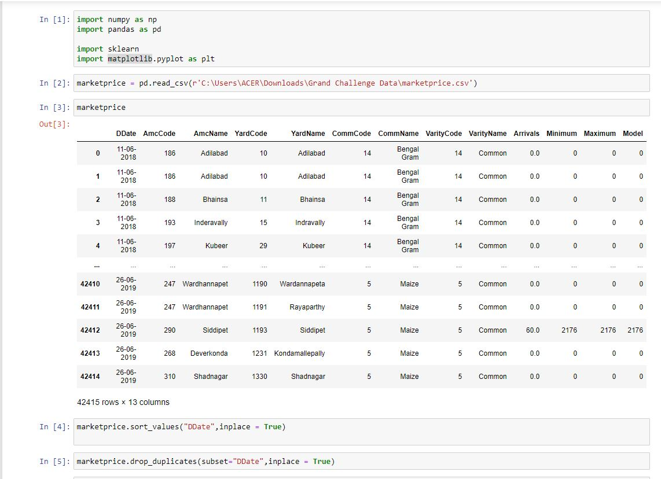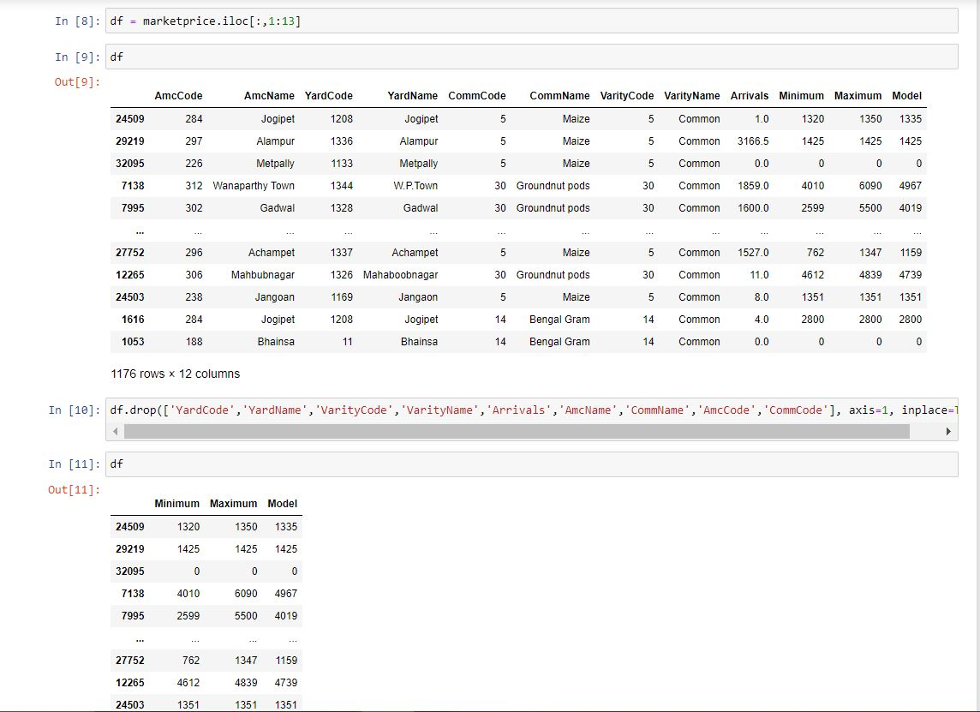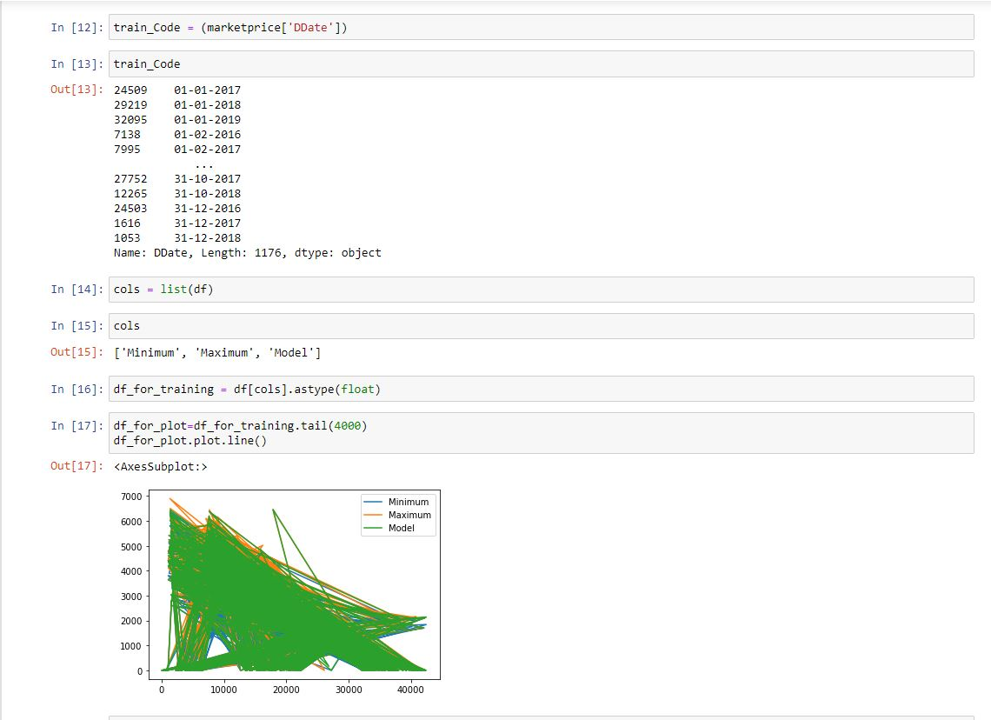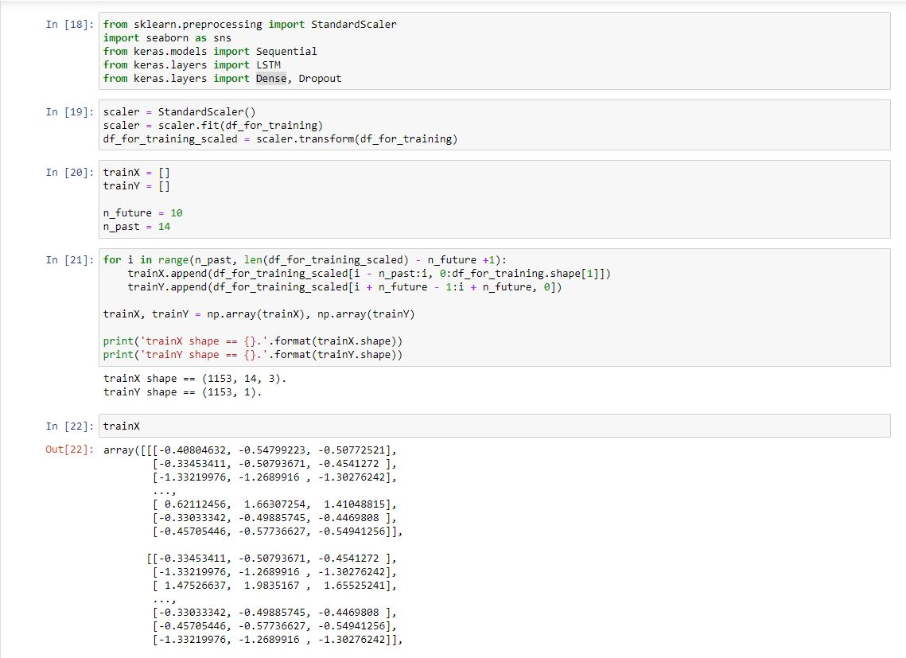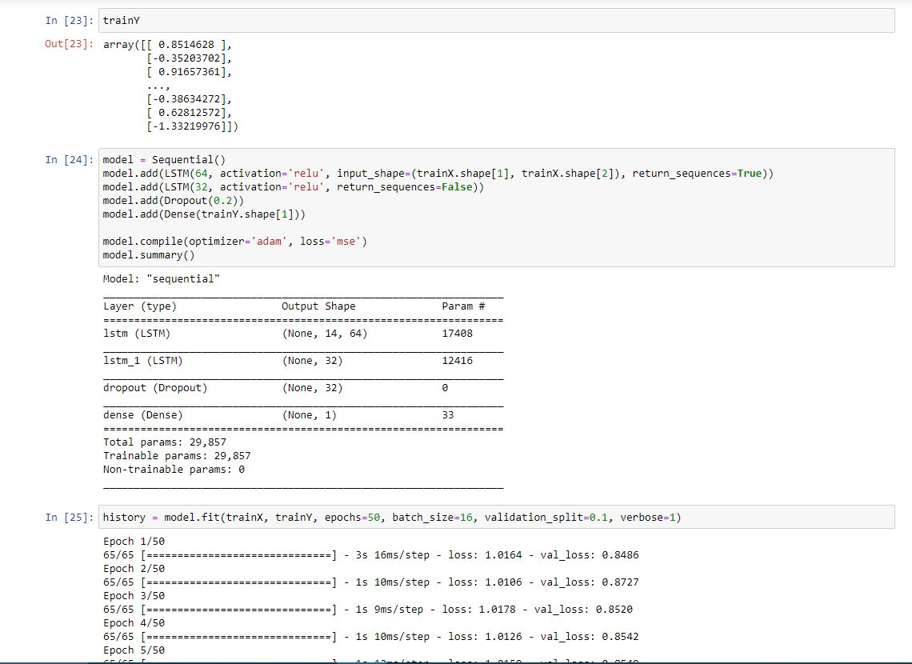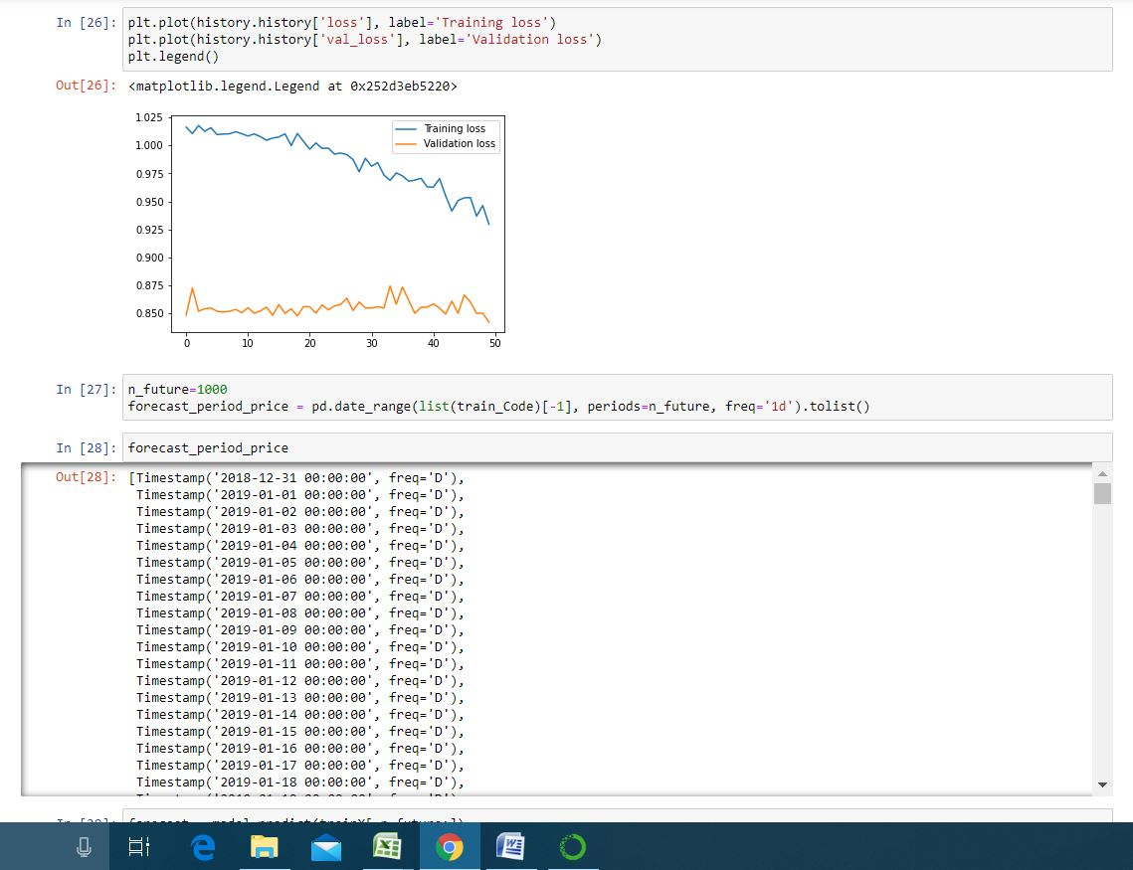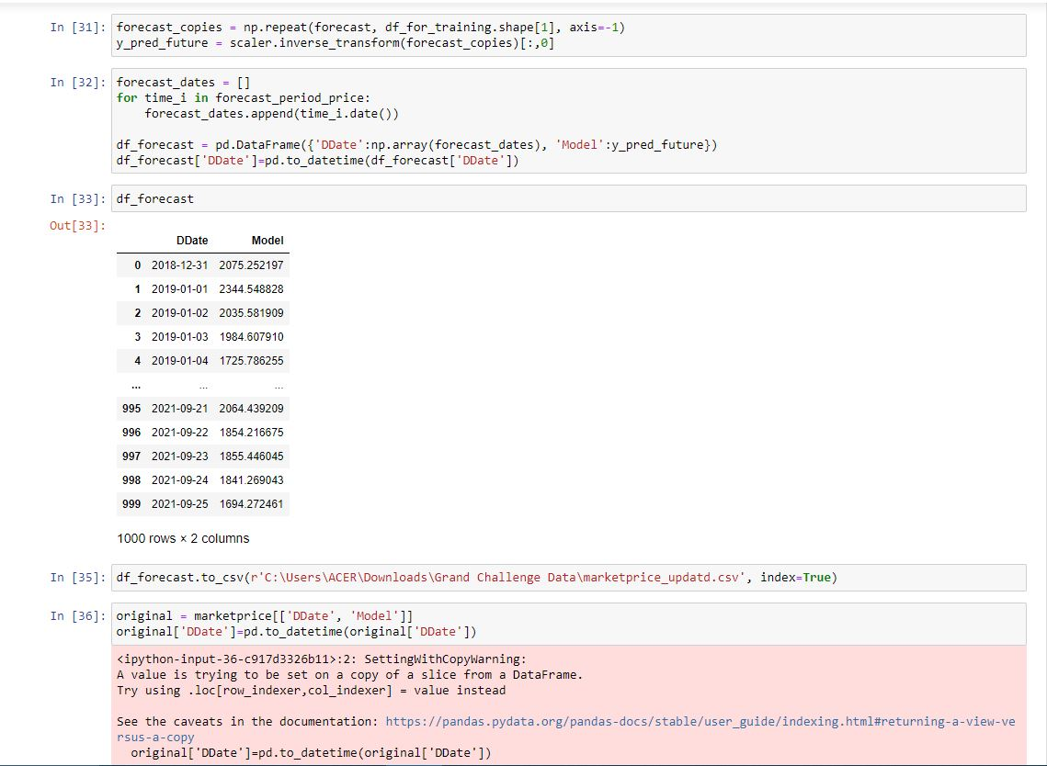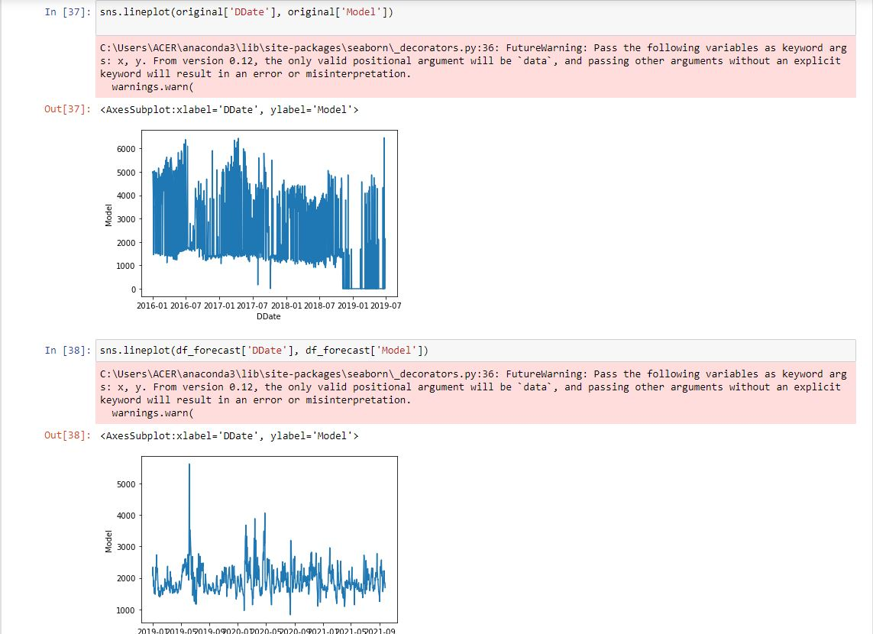

**Data Visualization**

This the MIN , MAX and MODEL(Predicted price)

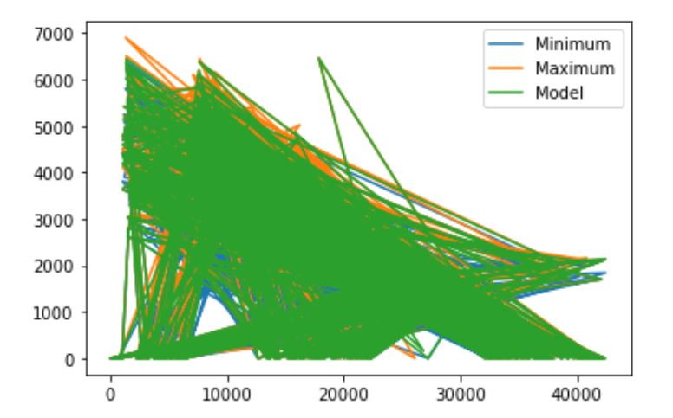

**Validation Loss and Training Loss**

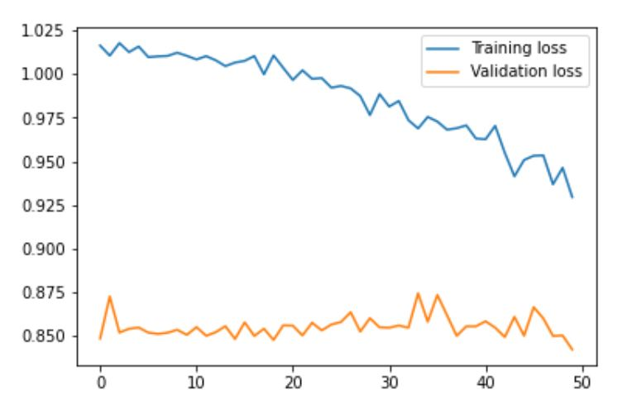

This the value before Prediction.

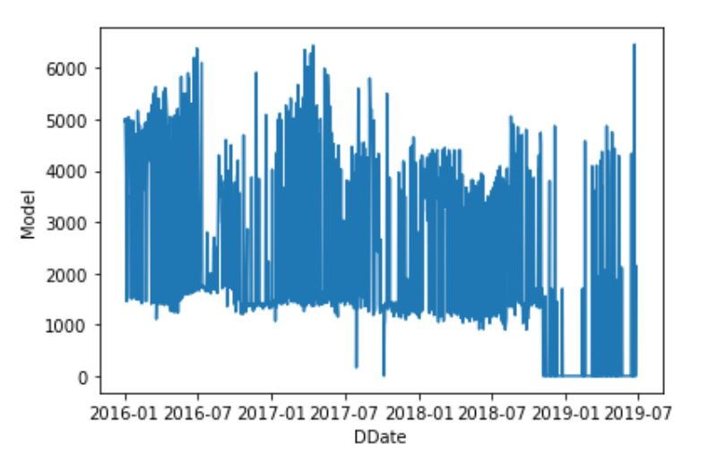

After Prediction

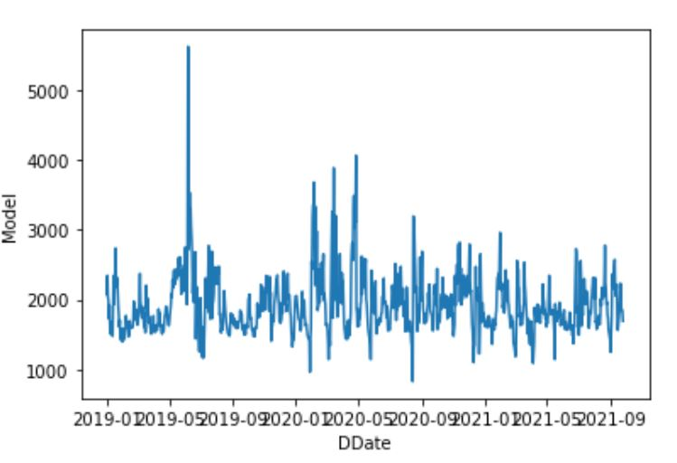

**Conclusion:**

The challenge was to provide a visualization for improving yield background in 3 growth stages depending on the variables given. using different variables like climate, season, market price we predicted the yield through an ML training algorithm and predicting it through an LSTM model .The discovery was to find the average price for 3 crops for the past 3 years in different district names of Telangana.

**References:**

[Data for Social Good Hackathon - Google Drive](https://drive.google.com/drive/folders/1aphj_6zfd500TShROuNBQqzT0_JbMsR8)

[Guided Projects (smartinternz.com)](https://smartinternz.com/guided-project/sdg-2-zero-hunger)